Are we really on Bumpy Flat?

By Aaron Close

I would like to thank Dr. Stoner for his detailed and thoughtful analysis of the future population of the Walsh school. I wish to first discuss the points I agree with him on. We can agree that there was an early phase of growth referred to by Dr. Stoner as Ripples of Manifest Destiny., This period is clearly visible in population growth data from Baca and surrounding counties as seen in Figure 1. Then, there was a transition period to a new domain of contraction. This transition started at the peak in 1930 prior to the Dustbowl and things settled into the exponential decline phase about 1950. In addition, the surrounding counties all experienced the same overall pattern of decreasing population which was well established during the last ~40 years since 1980 (Figure 2 & Figure 3). The only exception was Las Animas county which was left off because of the strong population influence associated with its population center in Trinidad along with the front range. Where my analysis of data diverges from Dr. Stoner’s is in the data from 2010 through the projections into the future. Here my analysis of both population trends as well as probable student body size for the Walsh schools differs significantly which could create undue costs if it leads to building a facility approximately 25% larger than necessary.

The Science Section

To begin with, I understand this section is fairly technical and can be a bit boring to some readers however I thought it important to include as it is the technical basis for my conclusions. If you want to skip this section, feel free and jump straight to the conclusions. Let me preface that scientists often disagree in these types of situations where extrapolation is needed as they are very dependent on the models used to make those projections.

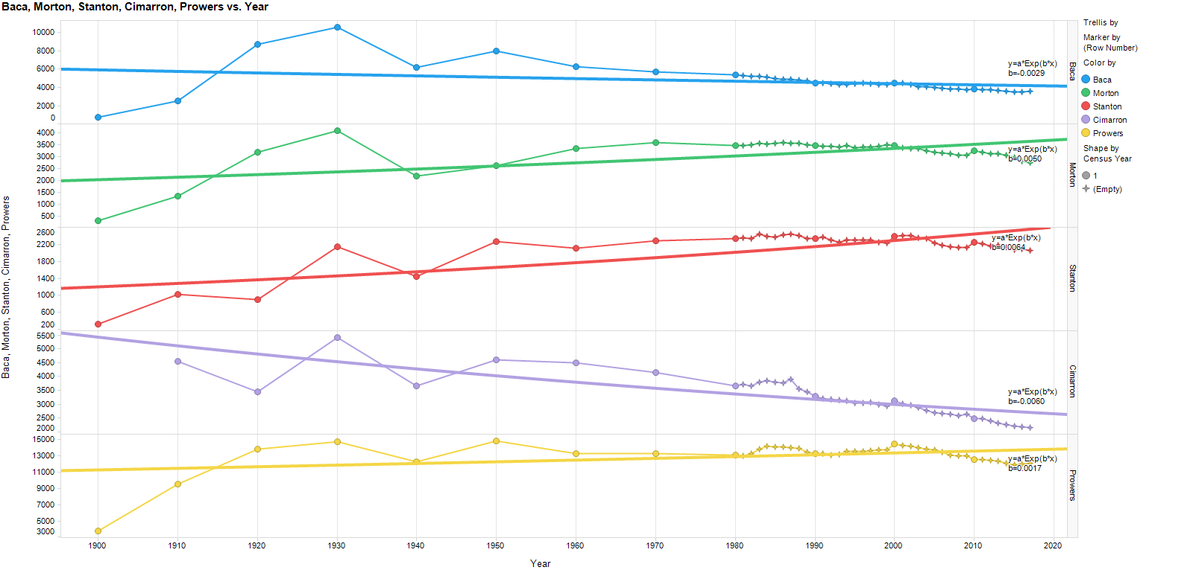

Figure 1 Population Data for Various Counties 1900 to current source US Census shows a poor correlation to the exponential model over the whole period

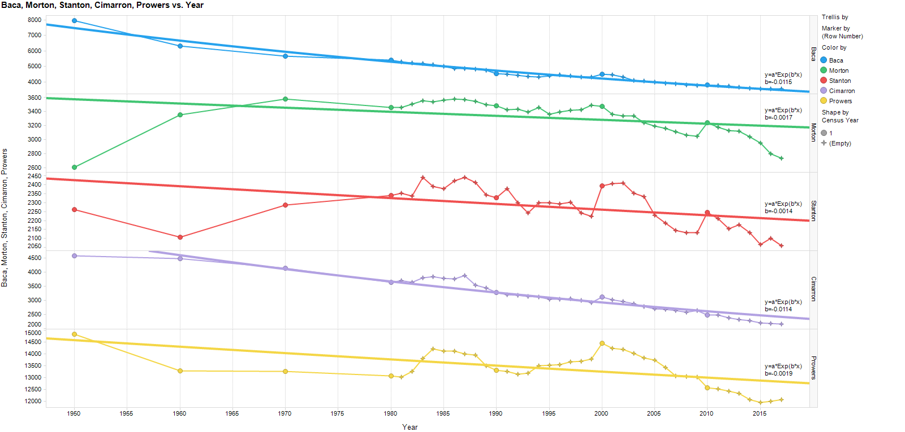

Figure 2 Population Data for Various Counties 1950 to current source US Census shows good correlation to the exponential model for both Baca and Cimarron Counties

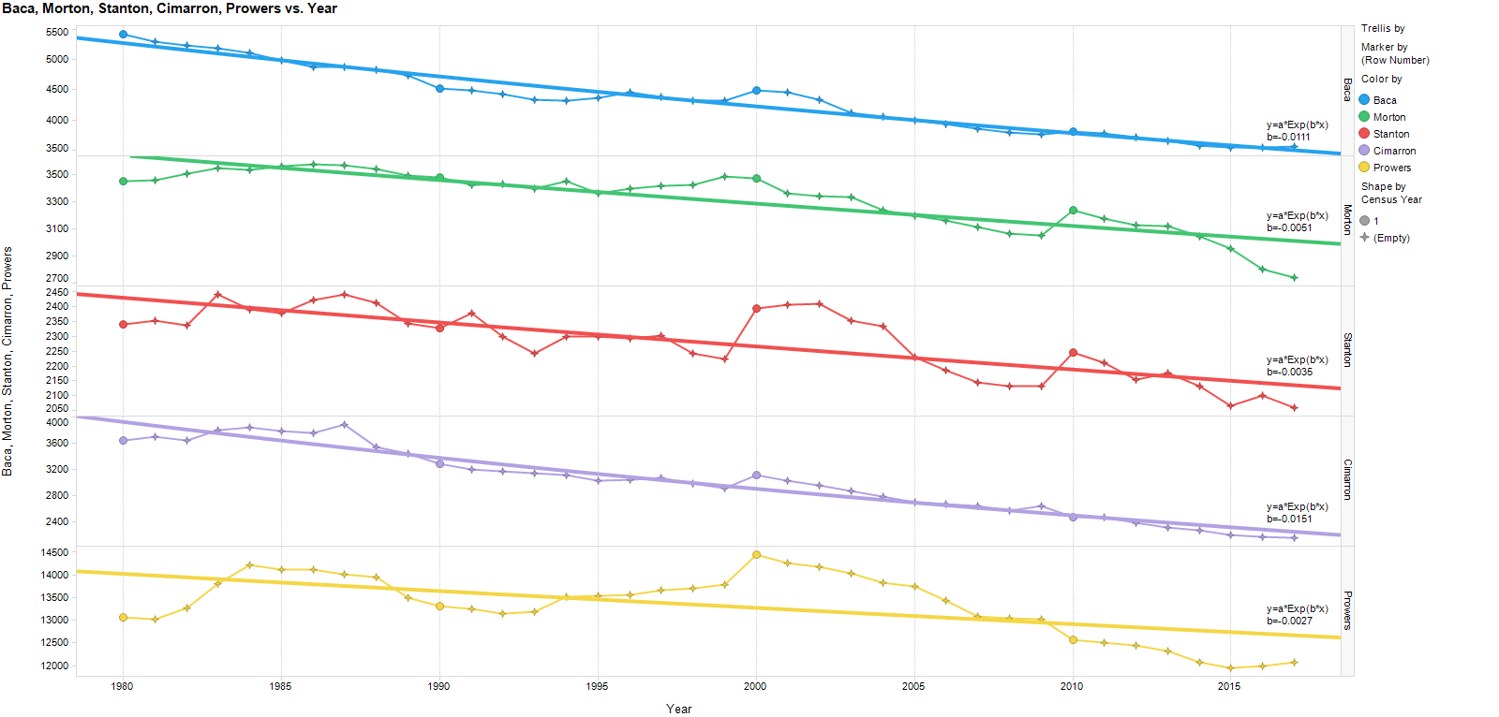

Figure 3 Population Data for Various Counties 1980 to current source US Census shows all adjacent counties have had declining populations since 1980 or longer.

My first point of divergence from Dr. Stoner is the interpretation that there has been another inflection point and we will be experiencing a different mode going forward. I would argue that the data does not show a change in the pattern. Figure 4 shows the fit to an exponential decline model for Baca and surrounding counties. The two columns include critical information for not only understanding the trends but also for understanding the certainty of them. First is the R squared column. An R^2 of 1 would be a perfect relationship between the model and the data and 100% of the variation in the data can be explained by the model, and 0 is no relationship between the model and data and model explains none of the variations in the data. As a general rule of thumb numbers over .75 are considered reliable, between .75 and .4 should be used with caution particularly if there is a small sample size, and below .4 are considered poor to no relationship. The second column is the Growth Rate from the fit model. A positive number means the population is growing and a negative number means it is shrinking. The number can be thought of like the annual percentage change of interest on an account. I have highlighted 5 rows in Figure 4, in each of these are rows there is a high degree of confidence in the fit. It should be noted that these are all the fits for Baca and Cimarron counties from 1950 to 2017 and from 1980 to 2017 and from Morton County from 1980 to 2017. All of the percentages show a strong relationship and a negative growth rate of between -.5% and -1.5%. This means that all the statistically significant population trends show negative growth. By looking at the plot you can see there is not any data yet showing a variation from that trend. This is not to say there could not be, only that it is not yet supported by the data. There may be good reasons to think the trend could change, and arguments such as the rise of telecommuting and other factors could affect that change, but as of now, the data indicates that populations are decreasing in the area.



Figure 4 Table showing the best fit models for each county during each period of study.

A series of models have been built showing what the average class size might look like in the future given different growth or shrinkage models in Figure 5. The 0% growth is equivalent to Dr. Stoners model and the -1% growth is close to this historic average of county population change since 1980. A high case where the growth of the county and by implication the school at 0.5% per year and a low case with population contraction accelerating at -1.5% were also included for reference.

Figure 5 Models of Walsh school mean population through time given different county growth assumptions

In addition, Dr. Stoner made a mathematical assumption that is very common and intuitive but incorrect which is that the variance of a sample of the population is the same as the variance of multiple samples combined of that population or the average. By way of example, the mean/average(μ) of the 15 classes size is by my calculation 11.053 and by his 12. To get to the average school population we agree that it is simply the average size times number of classes or 12\*15 for Dr. Stoner and 11.053\*15 for me. This is roughly the same, however, Dr. Stoner states that the dynamic range, in this case, implied 90% confidence interval was -/+ 60. I am not exactly sure how he got this number however, I will take a bit more rigorous approach. The 90% confidence interval implies that the values will lie between +/-1.645\*standard deviation (σ) + average for a single test. Which in my case the calculated standard deviation calculated from the class data provided by Dr. Stoner was 3.778 implying a 90% confidence interval of 17.27 to 4.8 students per class. However, this changes when we consider we are dealing with a total school population of 15 classes. In that case, we would expect the average class size to be the same however the standard deviation of the mean decreases due to being able to sample the distribution multiple times. As a result, we can expect the range of average standard deviations to then be reduced the $\frac{σ}{\sqrt{n}}$ where n is the number of samples or classes in this case. This means the sum of the standard distributions will be $\frac{σ}{\sqrt{n}}n$ which simplifies to $σ\sqrt{n}$ which means that we should expect the 90 % confidence interval for the whole school population to be $μn\frac{+}{-}1.645σ\sqrt{n}$ which works out to 11.053\*15 +/- (1.645\*3.77\*3.87) or 166+/-24. These are the theoretical numbers. To confirm them a Monte Carlo simulation was run using the normal distribution for the number of students in each class. Then modeling 15 independent classes and taking the total of those then iterating on that 10k times. This gives modeled distribution that should match our theoretical one as seen in Figure 6 and in fact it does, and you can see that with a 90% confidence you can say that it would be highly unlikely that the school would be required to be built for more than 190 total students. In addition, if the growth/contraction rates already seen in the county continue you would likely need even less space. 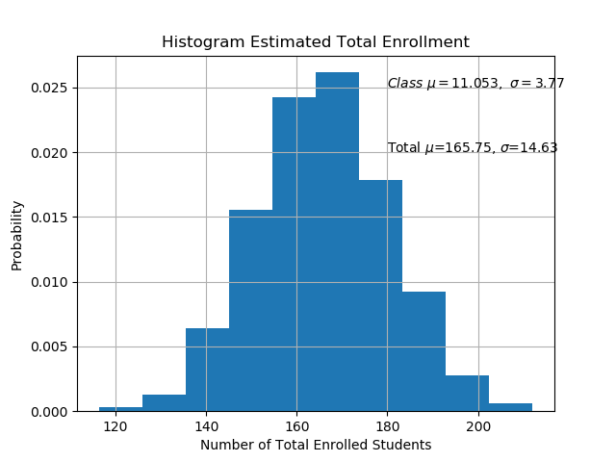

Figure 6 Results of Monte Carlo model to determine the probable range of total school size

Conclusions:

1. The statistical data available shows an average decline in population for Baca and surrounding counties of about 1% per year with no indication of this stopping.
2. The models and theory show that if population size stays stable the total Walsh School enrollment would likely be 166 students on average but could range as high as 190 and as low as 142.
3. It would be extremely unlikely that a school designed for 240 students would be ever be fully utilized.

Further Discussion and Personal Opinions:

Given the age of the schools in Baca county, two things are probable. First, given that they were built when there was a larger student population in every district, there is likely excess space at each existing school, and due to their age and condition, updating or replacing them may be preferable.

Knowing these two things I would ask a few questions.

1. Is building a new school the best use of taxpayer resources?
2. What are the other options?
   1. Consolidation of all Baca county schools?
   2. Consolidation of only JH and HS?
   3. Would a consolidated school offer more options for students in STEM, Arts, and Vocational Training?
3. What is the cost-benefit of renovation vs new school buildings?
4. How can modern technology be used enable innovative solutions?
5. Is it possible for students to telecommute to school some days of the week?
   1. If so, at what ages is this practical?
6. How do we keep a good student-teacher ratio, as studies have shown that it is the most effective way to improve student outcomes?

There are many questions that need discussion and consideration, I have not been part of the process but hope my contributions here are helpful and provide both an additional perspective on demographic trends as well as expected student body populations. I encourage the community leaders to think long term and to think outside the box. The Baca county community has a history of innovative and effective educational programs and I would love to see that continue by preparing all of our students for their futures no matter what that might be, while avoiding some of the expensive and burdensome over building projects I have seen in Texas that helped push property taxes up to more than 10 times what Baca county residents pay.

References and Source Data

Reference Article “Bumpy Flat” Dr. Bill Stoner, Plainsman Herald, Vol 131 Edition 3, Page 4 July, 24th 2019

Population data from census.gov July 25-26 2019.

All Reference data, models, code, and source information is available at in the public domain at <https://github.com/adclose/WalshSchool>

Special thanks for editing and feedback from Kathryn Close, Kayla Close, and Kyleen Willis